CHAPTER 3 HUMAN RESOURCE MANAGEMENT

3.1 Concept, aim ,& objectives of HRM/Personnel Management

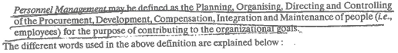

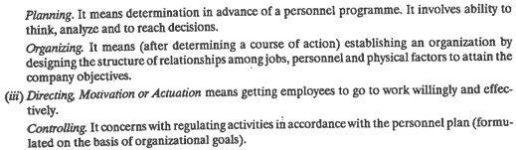





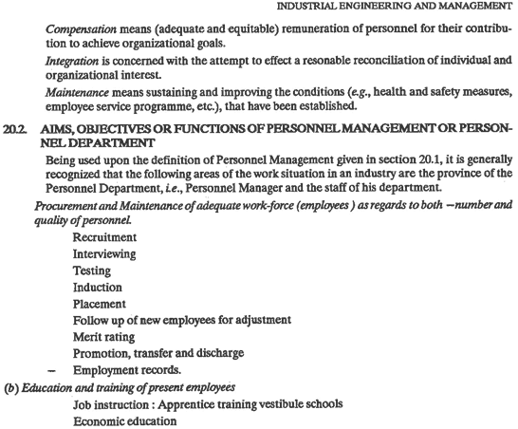

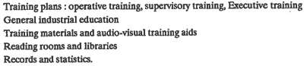

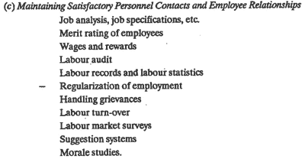

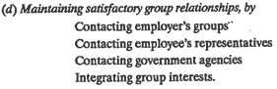

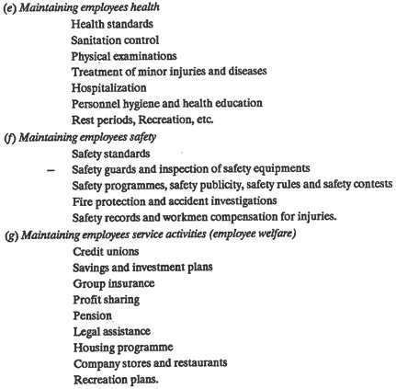

3.2 Functions of HRM

**1. Planning**

One of the primary function where number & type of employees needed to accomplish organizational goals are determined. Research forms core HRM planning which also helps management to collect,analyze and identify current plus future needs within the organization.

**2. Organizing**

Organization of the task is another important step. Task is allocated to every member as per their skills and activities are integrated towards a common goal.

**3. Directing**

This includes activating employees at different levels and making them contribute maximum towards organizational goal. Tapping maximum potentialities of an employee via constant motivation and command is a prime focus.

**4. Controlling**

Post planning, organizing and directing, performance of an employee is checked, verified and compared with goals. If actual performance is found deviated from the plan, control measures are taken.

**Operative Function Includes:**

**1. Recruitment/Hiring**

Hiring is a process which brings pool of prospective candidates who can help organization achieve their goals and allows managements to select right candidates from the given pool.

**2. Job Analysis & Design**

Describing nature of the job like qualification, skill, work experience required for specific job position is another important operative task. Whereas, job design includes outlining tasks, duties and responsibilities into a single work unit to achieve certain goal.

**3. Performance Appraisal**

Checking and analyzing employee performance is another important function that human resource management has to perform.

**4. Training & Development**

This function allows employees to acquire new skills and knowledge to perform their job effectively. Training and development also prepares employees for higher level responsibilities.

The training of the new employees and also of those who are being promoted is the crucial function of Personnel Department. A training programme is devised for this purpose. The training increases the skills and abilities of the employees.

**Need of Training**

A **training** program allows you to strengthen those skills that each employee needs to improve. A development program brings all employees to a higher level so they all have similar skills and knowledge. This helps reduce any weak links within the company who rely heavily on others to complete basic work tasks.

**The various aspects of training are:**

(a) Training to new employees, instructors and supervisors.

(b) Training in safety equipment and various policies of companies.

(c) Training through improvement of education such as evening classes, films, Entertainment programmes etc.

(d) Encouraging employees to give suggestions

**5. Salary Administration**

Human Resource Department also determines pays for different job types and incudes compensations, incentives, bonus, benefits etc. related with a job function.

**6. Employee Welfare**

This function takes care of numerous services, benefits and facilities provided to an employee for their well-being.

a) Provision of medical facilities such as first aid, dispensaries, etc.

(b) Suggesting ways and means by which accidents can be eliminated or minimised.

(c) To make provisions for restaurants and other recreational facilities.

(d) To apply the labour laws effectively.

(e) To publish a plant magazine.

**7. Maintenance**

Minimizing employee turnover and sustaining best performing employees within the organization is the key. Minimizing ROI within HR department is also a key goal for Human resource management team.

**8. Labour Relations**

Labour relation is regards to the workforce who work within a trade union. Employees in such domain form a union/group to voice their decisions affectively to the higher management.

**9. Personal Research**

Research is a vital part of human resource management. It is performed to keep a check on employee opinion about wages, promotions, work condition, welfare activities, leadership, employee satisfaction and other key issues.

**10. Personal Record**

This function involves recording, maintaining and retrieving employee related information including employment history, work hours, earning history etc.

13) Integration

Integration is concerned with the attempt to effect reconciliation of individual, organization and social interest. It involves infusing among employees a sense of belonging to the enterprise. The employees should identify their personal interest with that of the organization. They should have a feeling that everything good of the enterprise will also be in their interest. This will bring about harmony of interests both of employees and the organization. There should be proper communication channel at all levels. The grievances of employees should be redressed at the earliest. This will help in creating good industrial relations and will integrate them.

**14) Compensation:**

It is concerned with securing adequate and equitable remuneration to persons working in the organization. Job analysis will enable in fixing the remuneration for various jobs. The needs of the jobs and qualifications of persons who will take up those jobs should be taken into consideration while fixing remuneration. If the employees are paid less than they should have got, they may leave the job at an earliest opportunity. So compensation should be fixed in such a way that it is able to attract and retain suitable persons in the organization.

15)Motivation

Motivation of staff This is an extremely important function in personnel management and one of the major factors that determine the company's success. There are several types of motivations such as material, psychological and social. Motivation is more than just monetary bonuses. In general, there are some steps that can be taken to motivate the staff of a company; they include: The subordinates should realize their importance to the company and see the results of their activities. When a worker participates in important negotiations, goes on business trips, has a status in the company, this affects his performance favourably. Unexpected promotion. It may seem strange but unexpected encouragements and promotions affects the employee's performance much better than regular, predictable incentives. The immediate response of the administration to the actions of the employees is invaluable in increasing productivity. If an employee sees that his actions are not only noticed by superiors but also rewarded at once, he becomes highly motivated.

16)Industrial Relation

Relations mean the relations between people that can be taken at any level such as individual, international and national level. In work place, the relations have known as industrial relations. Industrial relation means the relationship between employers and employees in course of employment in industrial organizations. In a broad sense, the term Industrial Relations includes the relationship between the various unions, between the state and the unions as well as those between the various employers and the government. Relations of all those associated in an industry may be called Industrial Relations. Industrial Relations also comprise the relation between the state, employer’s and employee’s and the relationship among them.

16)Staffing

Staffing is defined as, “filling and keeping filled, positions in the organizational structure. This is done by identifying work-force requirements, inventorying the people available, recruiting, selecting, placing, promoting, appraising, planning the careers, compensating, training, developing existing staff or new recruits, so that they can accomplish their tasks effectively and efficiently.”

Methods of Training

**Methods of Training: On-the-job Training Method and Off-the-Job Methods!**

Management development is a systematic process of growth and development by which the managers develop their abilities to man­age. It is concerned with not only improving the performance of managers but also giving them opportunities for growth and develop­ment.

There are two methods through which managers can improve their knowledge and skills. One is through formal training and other is through on the job experiences. On the job training is very important since real learning takes place only when one practices what they have studied.

**1. On-the-job Training (OJT) Methods:**

This is the most common method of training in which a trainee is placed on a specific job and taught the skills and knowledge necessary to perform it.

**On-the-job training methods are as follows:**

**1. Job rotation:**

This training method involves movement of trainee from one job to another gain knowledge and experience from different job assignments. This method helps the trainee under­stand the problems of other employees.

**2. Coaching:**

Under this method, the trainee is placed under a particular supervisor who functions as a coach in training and provides feedback to the trainee. Sometimes the trainee may not get an opportunity to express his ideas.

**3. Job instructions:**

Also known as step-by-step training in which the trainer explains the way of doing the jobs to the trainee and in case of mistakes, corrects the trainee.

**4. Committee assignments:**

A group of trainees are asked to solve a given organizational problem by discussing the problem. This helps to improve team work.

**5. Internship training:**

Under this method, instructions through theoretical and practical aspects are provided to the trainees. Usually, students from the engineering and commerce colleges receive this type of training for a small stipend.

**2. Off-the-job Methods:**

On the job training methods have their own limitations, and in order to have the overall development of employee’s off-the-job training can also be imparted. The methods of training which are adopted for the development of employees away from the field of the job are known as off-the-job methods.

**The following are some of the off-the-job techniques:**

**1. Case study method:**

Usually case study deals with any problem confronted by a business which can be solved by an employee. The trainee is given an opportunity to analyse the case and come out with all possible solutions. This method can enhance analytic and critical thinking of an employee.

**2. Incident method:**

Incidents are prepared on the basis of actual situations which happened in different organizations and each employee in the training group is asked to make decisions as if it is a real-life situation. Later on, the entire group discusses the incident and takes decisions related to the incident on the basis of individual and group decisions.

**3. Role play:**

In this case also a problem situation is simulated asking the employee to assume the role of a particular person in the situation. The participant interacts with other participants assuming different roles. The whole play will be recorded and trainee gets an opportunity to examine their own performance.

**4. In-basket method:**

The employees are given information about an imaginary company, its activi­ties and products, HR employed and all data related to the firm. The trainee (employee under training) has to make notes, delegate tasks and prepare schedules within a specified time. This can develop situational judgments and quick decision making skills of employees.

**5. Business games:**

According to this method the trainees are divided into groups and each group has to discuss about various activities and functions of an imaginary organization. They will discuss and decide about various subjects like production, promotion, pricing etc. This gives result in co-operative decision making process.

**6. Grid training:**

It is a continuous and phased programme lasting for six years. It includes phases of planning development, implementation and evaluation. The grid takes into consideration parameters like concern for people and concern for people.

**7. Lectures:**

This will be a suitable method when the numbers of trainees are quite large. Lectures can be very much helpful in explaining the concepts and principles very clearly, and face to face interaction is very much possible.

**8. Simulation:**

Under this method an imaginary situation is created and trainees are asked to act on it. For e.g., assuming the role of a marketing manager solving the marketing problems or creating a new strategy etc.

**9. Management education:**

At present universities and management institutes gives great emphasis on management education. For e.g., Mumbai University has started bachelors and postgraduate degree in Management. Many management Institutes provide not only degrees but also hands on experience having collaboration with business concerns.

**10. Conferences:**

A meeting of several people to discuss any subject is called conference. Each par­ticipant contributes by analyzing and discussing various issues related to the topic. Everyone can express their own view point.

3.3 Safety engineering:

Need

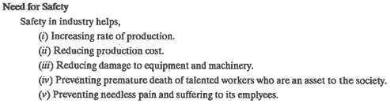

Organization

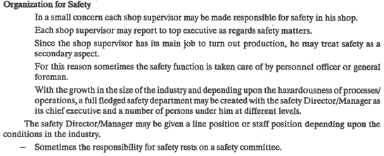

Safety Committee

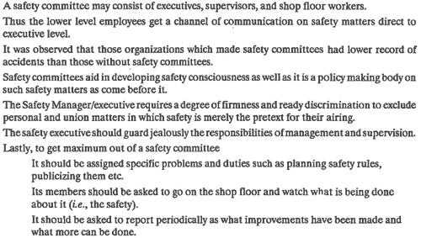

Safety Programme

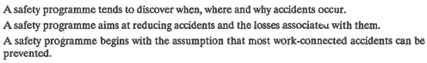

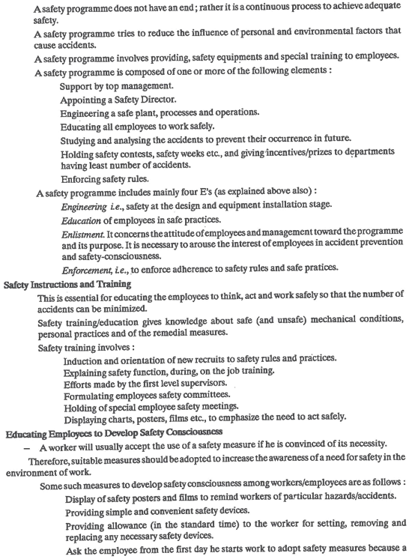

.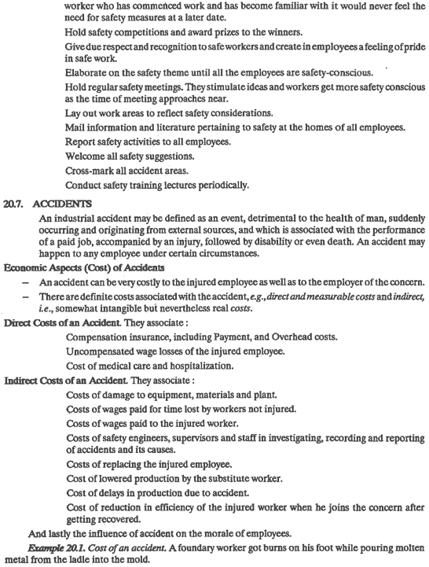

Accidents: causes



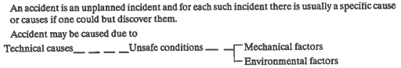

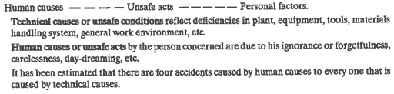

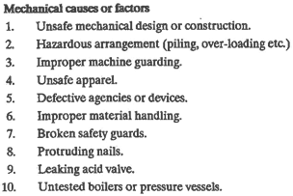

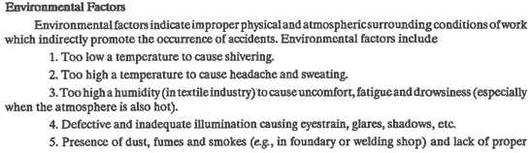







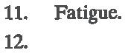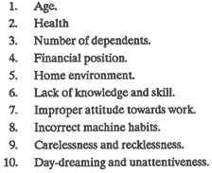

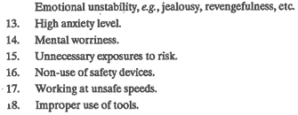



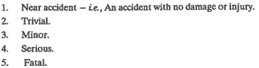

Prevention.



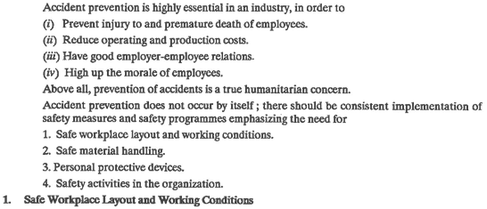

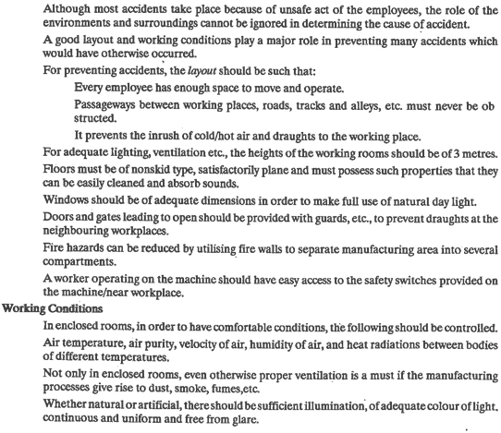

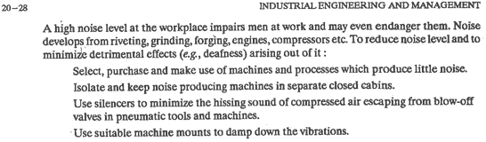

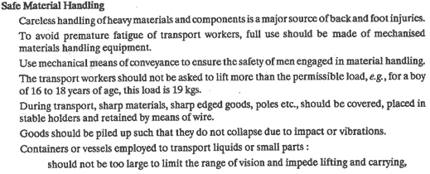

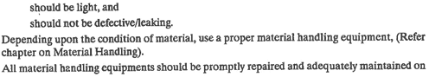





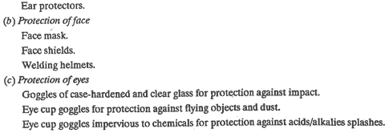







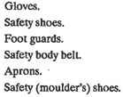

3.4 Characteristics of supervisors,

1. Gives clear work instructions: communicates well in general, keeps others informed.
2. Praises others when they deserve it: understands importance of recognition; looks for opportunities to build the esteem of others.
3. Willing to take time to listen: aware of value of listening both for building cooperative relationships avoiding tension and grievances.
4. Cool and calm most of the time: maintains self-control, doesn't lose her/his temper; can be counted on to behave maturely and appropriately.
5. Confident and self-assured.
6. Appropriate technical knowledge of the work being supervised; uses it to coach, teach and evaluate rather than getting involved in doing the work itself.
7. Understands the group's problems as demonstrated by attentive listening and honestly trying to project her/himself into their situation.
8. Gains the group's respect, through personal honesty: doesn't try to appear more knowledgeable than is true, not afraid to say, "I don't know" or "I made a mistake."
9. Fair to everyone; in work assignments, consistent enforcement of policies and procedures; avoids favoritism.
10. Demands good work from everyone: maintains consistent standards of performance; doesn't expect group to "take up the slack" from a low-performing worker; enforces work discipline.
11. Gains the people's trust: willing to represent the group to higher management, regardless of agreement or disagreement with them.
12. Goes to bat for the group: will work for best and fair interests of the work group; loyalty to both higher management and the work group.
13. Humble, "not stuck up"; remembers that s/he's simply a person with a different job to do than the workers s/he supervises.
14. Easy to talk to: demonstrates a desire to understand without shutting off feedback through scolding, judging, moralizing.

styles of supervision & its advantages and limitations.

* **Coaching**: A coaching leader focuses on one-on-one development with an employee. This relationship often looks like that of a mentor and mentee. The coach helps develop an individual to get the most out of their performance, priming them for bigger things. First, the coach must learn the worker’s strengths and weaknesses. Then, it’s time to hone their skills and take them to the next level. Coaching is an excellent supervisory style to use when an employee or team member is struggling or becoming disengaged from their work. It can also work for highly motivated individuals who are looking to gain promotion. In any case, coaching is a motivating style of leadership. However, it may be difficult to implement for an entire team, especially if it’s a large team. * **Affiliative**: An affiliative leader encourages teamwork and brings workers together. Affiliative leadership is often used to boost morale or bring a disjointed team together. This style of leadership is positive, encouraging and social. That said, the affiliative supervisory style doesn’t work in all contexts. It’s great to connect employees and boost engagement with one another. This style of leadership is best used in conjunction with other leadership styles. * **Pacesetting**: A pacesetting leader sets a high bar and expects all employees to reach it. This leader is continually working to improve performance, efficiency and outcomes. While pacesetting can be motivating up to a point, this supervisory style can occasionally leave employees feeling overwhelmed and frustrated. Nobody wants to feel like they are constantly failing. If the bar is being set too high and goals are not achievable (or goals are only attainable by overextending oneself) employees will eventually lose motivation. For this reason, pacesetting should be used sparingly, and in concurrence with other supervisory styles. * **Transformational**: A transformational leader wants nothing more than to make a change. This person motivates every team member with their strong communication skills, empathy and vision. Transformational leaders have a high level of social intelligence and a knack for elevating everyone around them. If anyone can realize the potential of an organization, it’s a transformational leader. [Transformational leadership](https://bizfluent.com/info-8146616-transformational-leadership-styles.html) is often cited as the most desired and successful supervisory style. * **Transactional**: A transactional leader prefers to establish a clear chain of command, with every person on the team having a defined role. This person treats work as a transaction. Good work is rewarded, while poor work is frowned upon. In some ways, this can be motivating to employees, as they are driven by the potential reward of a job well done. However, the transactional leader doesn’t leave much room for creativity or out-of-the-box thinking. This leader likes to keep things neat and traditional. * **Servant**: A servant leader is the ultimate team player. Tending to lead by example, this person motivates all those around them. Sometimes, a servant leader is not in an official position of leadership, yet others naturally gravitate towards their example. These leaders work hard, show integrity and embody strong company values. A servant leader also consults all team members on decisions. Further, this leader is likely to take responsibility for team failures, while giving the team all of the credit for wins. Employees usually feel respect and loyalty for leaders who use this supervisory style. * **Autocratic (authoritarian):** An [autocratic leader](https://bizfluent.com/info-8685178-autocratic-decisionmaking-style.html) makes all the decisions without the input of the team. This person believes they know best, and doesn’t trust others to take the lead. Autocratic leaders are controlling and authoritative. They don’t leave much room for input. While common, this supervisory style can cause employees to lose interest in work, or check out completely. * [**Laissez-faire](https://bizfluent.com/info-8399492-characteristics-laissezfaire-management.html)(delegative)**: A laissez-faire or delegative leader is the polar opposite of an autocratic leader. This person lets their employees do what they wish with relatively little supervision or direction. The delegative leader exercises a hands-off approach, allowing workers to handle tasks as they see fit. In some cases, this supervisory style makes sense. One example would be in a creative field when the team is highly experienced, and team members perform best independently. However, for a team that requires direction and communication, a delegative leadership style is less than ideal. \***Democratic/participatory**: A**[**democratic or participative leader**](https://bizfluent.com/info-8660426-characteristics-make-up-democratic-leader.html)**includes team member input in all decisions, but ultimately makes the final call. This leader also encourages the team’s creativity and engagement in projects. Because of the participatory process, teams under democratic leaders can have slower results and lower productivity. However, employees turn in higher quality work under democratic leadership and enjoy a high level of job satisfaction. This leadership style is known as one of the strongest supervisory styles. \***Bureaucratic**: The bureaucratic leader is a stickler for the rules, and prefers to follow procedures to the letter. For certain highly-regulated industries such as manufacturing work, or jobs where safety is a chief concern, bureaucratic leadership is successful. In creative or problem-solving fields, this supervisory style is likely too strict and by-the-book. \***Charismatic (visionary)**: A**[**charismatic leader**](https://bizfluent.com/about-7416354-charismatic-leadership-theories.html)**has a large, undeniable presence. This person’s strong personality tends to inspire loyalty among their team members. A charismatic leader is highly influential. On the other hand, this type of leader is often bigger than the team or organization itself. A charismatic leader’s personality is at the center of their work, and a project may fail without the leader’s involvement. Further, this leader is often so focused on their vision that they lose sight of other priorities. \***Situational**: A [situational leader](https://bizfluent.com/info-7851680-situational-leadership-pro-cons.html) utilizes elements from every type of leadership when necessary. This style of leadership is adaptive and flexible. A situational leader chooses the supervisory style a particular situation calls for. Because of this, many experts consider [situational leadership](https://bizfluent.com/about-6721035-definition-situational-leadership.html) to be among the strongest styles of leadership.

**Supervisor's** basic **role** is to plan the daily work schedule of the workers by guiding them the nature of their work and also dividing the work amongst the workers according to their interests, aptitudes, skills and interests.

functions of supervisors

Supervisor, being the manager in a direct contact with the operatives, has got multifarious function to perform. The objective behind performance of these functions is to bring stability and soundness in the organization which can be secured through increase in profits which is an end result of higher productivity. Therefore, a supervisor should be concerned with performing the following functions -

1. **Planning and Organizing -** Supervisor’s basic role is to plan the daily work schedule of the workers by guiding them the nature of their work and also dividing the work amongst the workers according to their interests, aptitudes, skills and interests.
2. **Provision of working conditions -** A supervisor plays an important role in the physical setting of the factory and in arranging the physical resources at right place. This involves providing proper sitting place, ventilation, lighting, water facilities etc. to workers. His main responsibility is here to provide healthy and hygienic condition to the workers.
3. **Leadership and Guidance -** A supervisor is the leader of workers under him. He leads the workers and influences them to work their best. He also guides the workers by fixing production targets and by providing them instruction and guidelines to achieve those targets.
4. **Motivation -** A supervisor plays an important role by providing different incentives to workers to perform better. There are different monetary and non-monetary incentives which can inspire the workers to work better.
5. **Controlling -** Controlling is an important function performed by supervisor. This will involve
   1. Recording the actual performance against the time schedule.
   2. Checking of progress of work.
   3. Finding out deviations if any and making solutions
   4. If not independently solved, reporting it to top management.
6. **Linking Pin -** A supervisor proves to be a linking pin between management and workers. He communicates the policies of management to workers also passes instructions to them on behalf of management. On the other hand, he has a close contact with the workers and therefore can interact the problems, complaints, suggestions, etc to the management. In this way, he communicates workers problems and brings it to the notice of management.
7. **Grievance Handling -** The supervisor can handle the grievances of the workers effectively for this he has to do the following things :-
   1. He can be in direct touch with workers.
   2. By winning the confidence of the workers by solving their problems.
   3. By taking worker problems on humanitarian grounds.
   4. If he cannot tackle it independently, he can take the help and advice of management to solve it.
8. **Reporting -** A supervisor has got an important role to report about the cost, quality and any such output which can be responsible for increasing productivity. Factors like cost, output, performance, quality, etc can be reported continually to the management.
9. **Introducing new work methods -** The supervisor here has to be conscious about the environment of market and competition present. Therefore he can innovate the techniques of production. He can shift the workers into fresh schedules whenever possible. He can also try this best to keep on changing and improving to the physical environment around the workers. This will result in
   1. Higher productivity,
   2. High Morale of Workers,
   3. Satisfying working condition,
   4. Improving human relations,
   5. Higher Profits, and
   6. High Stability
10. **Enforcing Discipline -** A supervisor can undertake many steps to maintain discipline in the concern by regulating checks and measures, strictness in orders and instructions, keeping an account of general discipline of factory, implementing penalties and punishments for the indiscipline workers. All these above steps help in improving the overall discipline of the factory.

3.5 Industrial act: Need,

1) Improves industrial relation i.e. employee-employer relations and minimizes industrial disputes.

(2) Prospects workers form exploitation by the employers or management

(3) Helps workers in getting fair wages

(4) Minimizes labour unrest

. (5) Reduces conflicts and strikes etc.

(6) Ensures job security for workers

(7) Promotes welcome environment conditions in the industrial system

(8) Fixes rest pauses and work hours etc.

(9) Provides compensation to workers, who are victims of accidents.

Factory act 1948,

**Objective of Factories Act ,1948**  
The main objectives of the Indian Factories Act, 1948are to regulate the working conditions in factories, to regulate health, safety welfare, and annual leave and enact special provision in respect of young persons, women and children who work in the factories.  
  
**1.Working Hours:**  
According to the provision of working hours of adults, no adult worker shall be required or allowed to work in a factory for more than 48 hours in a week. There should be a weekly holiday.  
  
**2.Health:**  
For protecting the health of workers, the Act lays down that every factory shall be kept clean and all necessary precautions shall be taken in this regard. The factories should have proper drainage system, adequate lighting, ventilation, temperature etc.  
  
Adequate arrangements for drinking water should be made. Sufficient latrine and urinals should be provided at convenient places. These should be easily accessible to workers and must be kept cleaned.  
  
**3. Safety:**  
In order to provide safety to the workers, the Act provides that the machinery should be fenced, no young person shall work at any dangerous machine, in confined spaces, there should be provision for man­holes of adequate size so that in case of emergency the workers can escape.  
  
**4. Welfare:**  
For the welfare of the workers, the Act provides that in every factory adequate and suitable facilities for washing should be provided and maintained for the use of workers.  
  
Facilities for storing and drying clothing, facilities for sitting, first-aid appliances, shelters, rest rooms’ and lunch rooms, crèches, should be there.  
  
**5. Penalties:-**  
The provisions of The Factories Act, 1948, or any rules made under the Act, or any order given in writing under the Act is violated, it is treated as an offence. The following penalties can be imposed:-  
(a) Imprisonment for a term which may extend to one year;  
(b) Fine which may extend to one lakh rupees; or  
(c) Both fine and imprisonment.

**Importance of Factories Act, 1948**  
The Factories Act, 1948 is a beneficial legislation. The aim and object of the Act is essentially to safeguard the interests of workers, stop their exploitation and take care of their safety, hygiene and welfare at their places of work. It casts various obligations, duties and responsibilities on the occupier of a factory and also on the factory manager. Amendments to the Act and court decisions have further extended the nature and scope of the concept of occupier, especially vis-a-vis hazardous processes in factories.

ESI act,

Employees' State Insurance (abbreviated as **ESI**) is a self-financing social security and health insurance scheme for Indian workers. This fund is managed by the Employees' State Insurance Corporation (**ESIC**) according to rules and regulations stipulated in the **ESI Act** 1948.

**Benefits of ESI Registration**

1. Medical Benefit. Full medical care is provided to all persons registered under ESI and their family members – from the day the person enters insurable employment. ...
2. Sickness Benefit. ...
3. Disablement Benefit. ...
4. Dependant Benefit. ...
5. Funeral Expenses. ...
6. Unemployment Allowance.

Workmen compensation act

The **objective** of the **Workmen** (now Employee) **Compensation Act**, 1923, as defined in the **Act** is… “… to provide for the payment of **compensation** by certain employers to their employees for injury caused to them by accident while in employment.

**Applicability of the Act**

The Employees Compensation Act applies to the following entities are listed below:

* It applies to employees working in factories, mines, docks, construction establishments, plantations, oilfields and other establishments listed in Schedule II of the Employee’s Compensation Act.
* It applies to persons recruited for working abroad and who is employed outside India as in Schedule II of the Act.
* It applies to a person recruited as the driver, helper, mechanic, cleaner or any other in connection with a motor vehicle and to a captain or other member of the crew of an aircraft.
* Also, the act does not apply to the members of armed forces of the Union & Workmen who are covered under ESI (Employee State Insurance) Act.

**Employer’s Liabilities for Compensation**

An employer is responsible for paying compensation to the employee under the following circumstances are:

* Personal injury by accident- An employer is responsible for paying compensation to workman if personal injury is let to him by accident arising out during his employment.
* Occupational diseases- workers employed in certain occupations are exposed to certain diseases which are inherent in that occupation.

An employer who is not liable for paying compensation to workers under the following conditions:

* In case of any injury which does not result in the partial or total disablement of the workers for a period exceeding three days.
* In case of any injury, not resulting in death or permanent total disablement, caused by an accident which is directly attributable to the following:
  + the workman present at the time thereof under the influence of drink or drugs.
  + the intentional disobedience of the workman to an order expressly given, or to a rule framed, to secure the safety of workers,
  + thewillful removal or disregard by the workman of any safety guard or other devices which he knew to have been provided for securing the safety of workers.